**Is It Sensory or Behavior?**

This is the BIG question parents, educators and professionals are asking and debating. Sensory Processing Disorder is a complex and easily misunderstood diagnosis that leads to behaviors. Parents and educators can become paralyzed in knowing how to discipline and support “meltdown moments” and society, unfortunately makes judgments. This training will provide you with the knowledge to help determine if behaviors are triggered by sensory needs or deficits. You will learn to see the clues to help determine the root cause and be provided with strategies, supports and a toolbox for your classroom, facility or home.

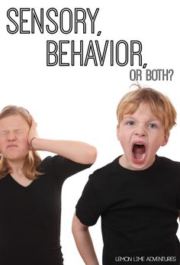

Call to schedule your in-service at 508 865-3421 or email us at gigiiadarola@gmail.com.